# Challenge 3 – Docker Deployments

## TIP – NextJs Project

This was pretty easy, simple and straight forward since it was a static website with no dynamic databases linked to it.

I first learned about docker from youtube and other platforms to know what the heck it is since I had no knowledge of it prior. I made Dockerfile with help of chat gpt.

I first ran it without compose and it ran easily. Later when I made docker compose file then I got error about npm not being found and that made allot of fuss for about 3-4 hrs. So I dropped it

Next day I started it all over on a different laptop which had nothing installed on it and there It worked.

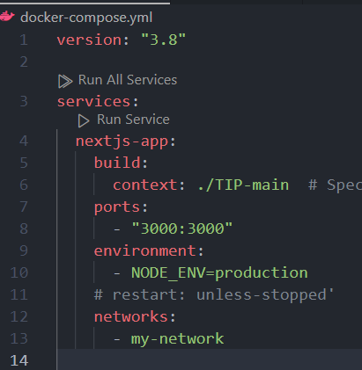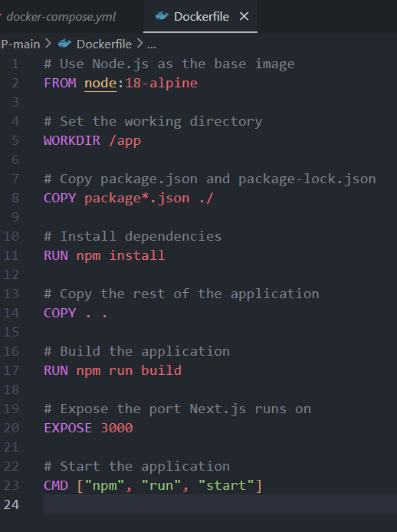

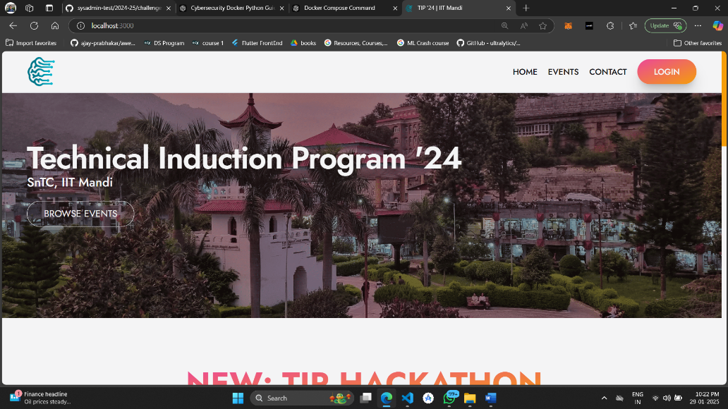I am using bridge network since I want to keep my containers isolated from other containers and only exposed to host via the the ports required by the app.

## [Nutrient-Tracker](https://github.com/aaltamirano1/Nutrient-Tracker) - A Ruby on Rails project.

This was one hell of a challenge sicne Idk anything about ruby or webdev or sql and about how all this stuff works and functions

I made several prompts to chatgpt which helped me reach a conclusion for this repo. I started of with static code where I got database error. Then I linked database by adding the command for it in dockerfile and compose file. Then I got some data migration error which I again tried to solve but got some error about system not being able to find some file in the project. Then I managed to find the right location for that file and then took another 30 min to finally solve the migration error. Then I had hope it would run correctly without any error. I rebuilt my container and finally got no error in the console. When I opened the website, I had a syntax error in ‘devise’ code which was a service for ruby developer to setup authentication and login in their websites and I was like TF bruh.

I looked up the github repo only to find that the ruby code was over 8 years ago. I tried lowering the ruby and rails and devise versions but all would not work. Then I went to SAIC PYQs to find a similar question in past and I did find on just last year. There also the code was 7-8 years ago. I found 2 things in the answer key of Piyush Panpaliya. Firsty I got to know about ‘therubyracer’ which was now depreciated but worked correctly the for current ruby version in the project. Secondly I found that the gemfile of the ruby codebase of the last years question had ruby and rails version listed in the gemfile but the gemfile of our question did not provide me with exact ruby version of the project which made it incredibly hard to solve. Moreover the syntax error was in ‘devise’ authentication since the newer version was not compatible with older ruby version.

‘therubyracer’ did not help me since it was linked to some js version. Then I played around I bit with the versions and read about the version of ‘devise’ that was in the project and it was compatible with which version of Ruby since I could not change devise version but I could change the ruby version I was installing in my docker. Then about 2-3 hrs of hustle….. The HUSTLER WON. Website was up and runnin baby

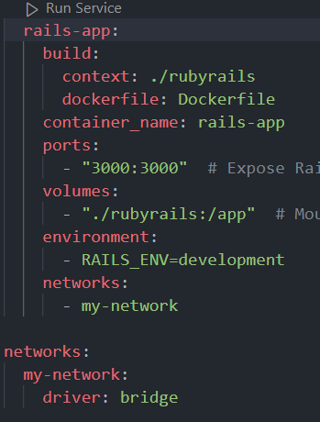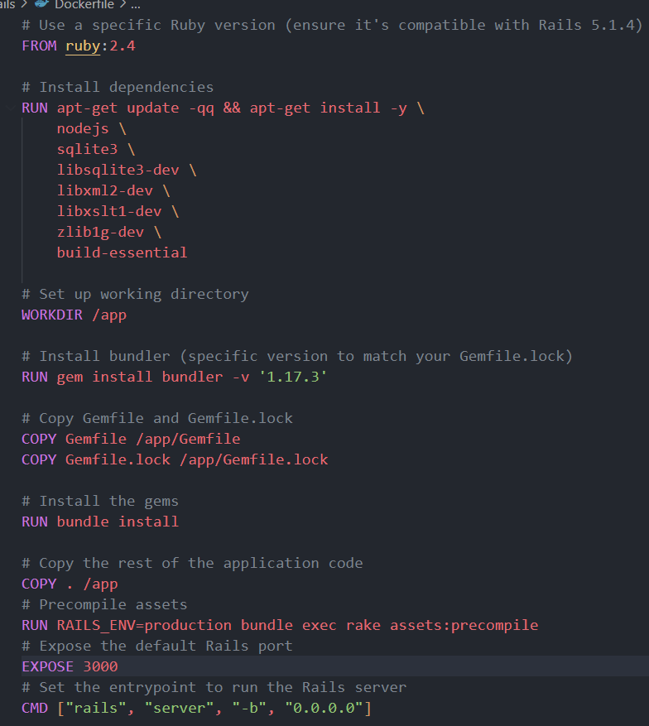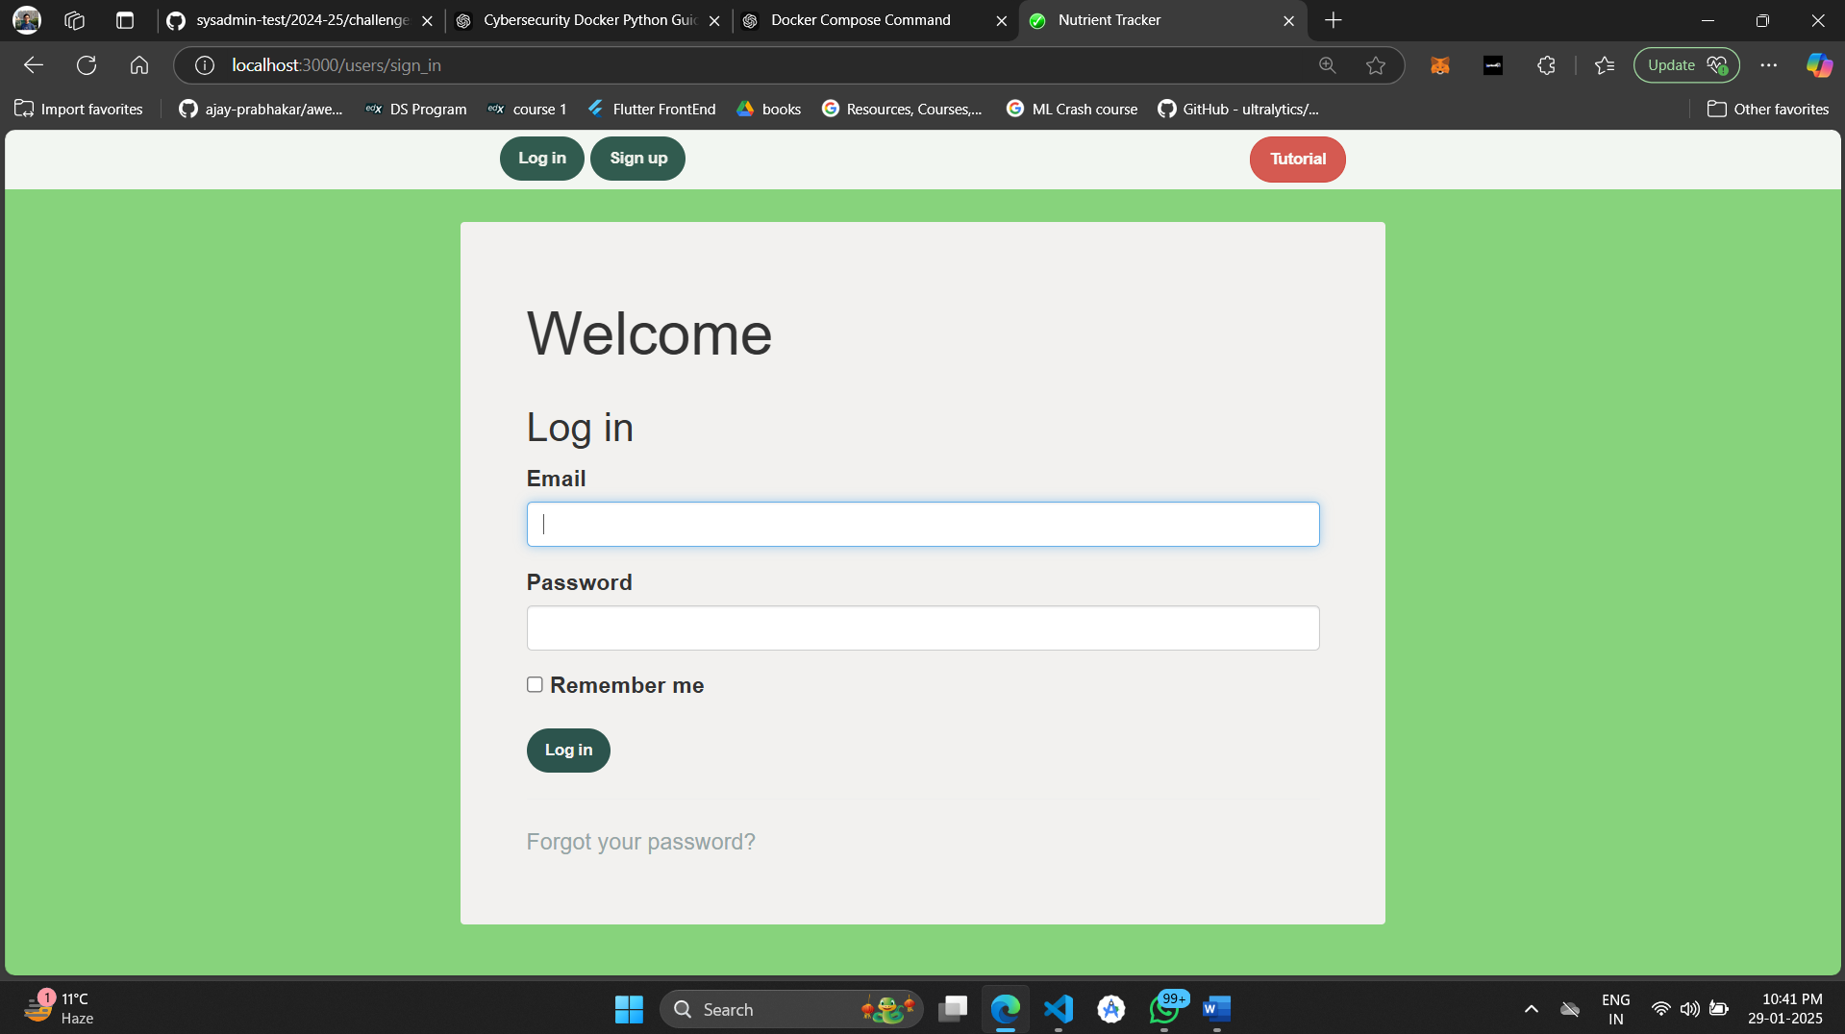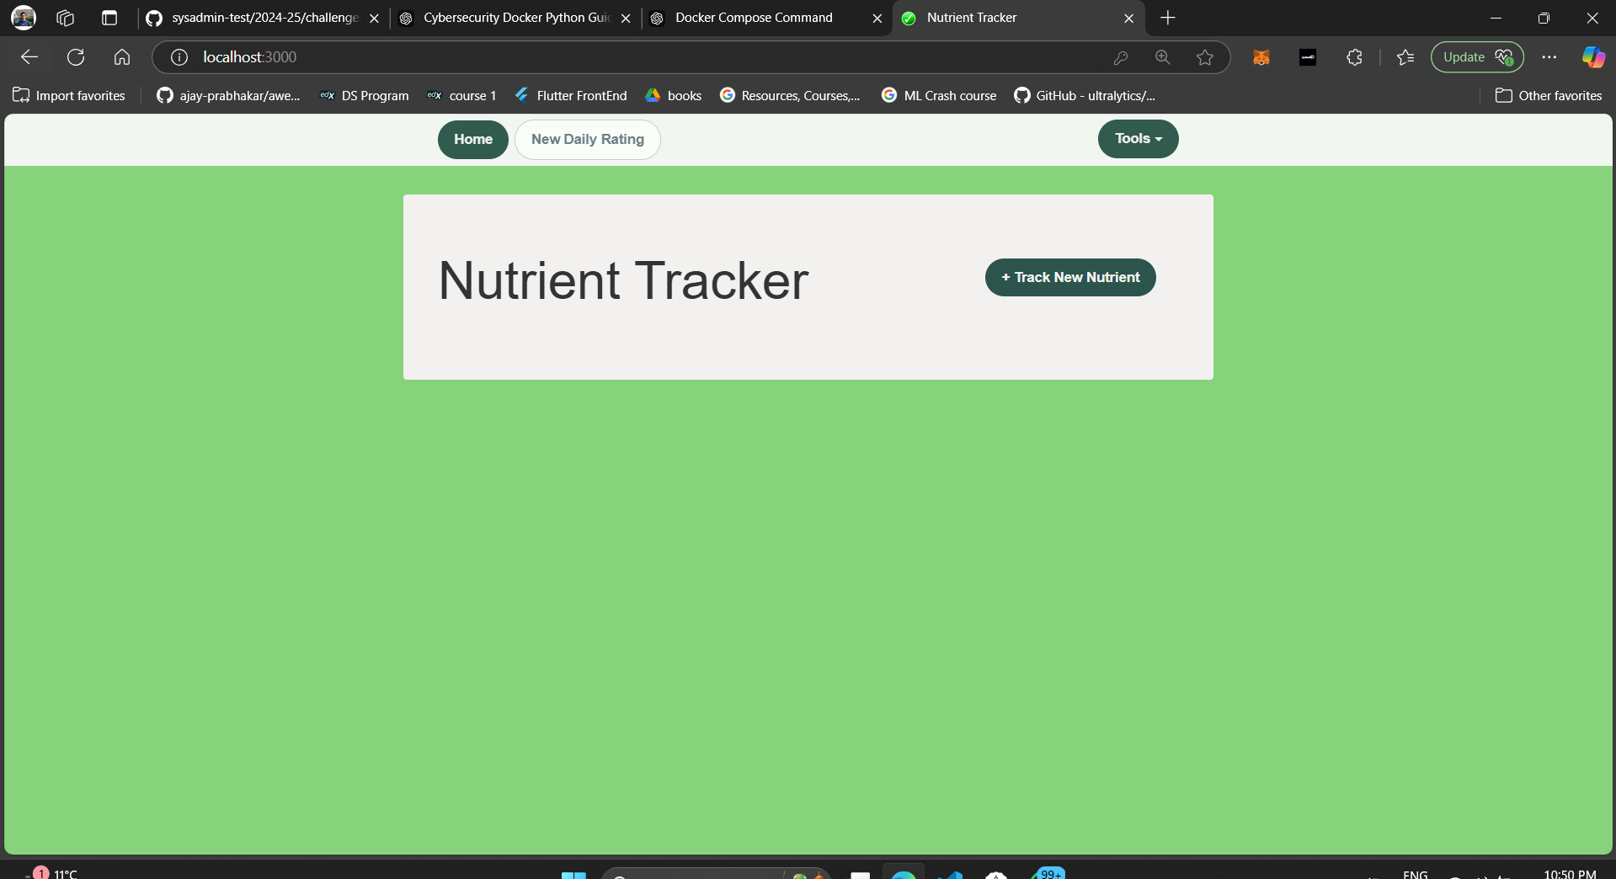

Ruby part was real hard. But ham bhi SAIC – aspirant hainn.. aise kaise jaane den!